7.22: a) The work done by friction is
so 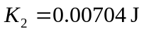 and 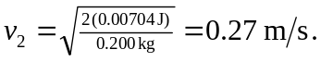 b) In this case 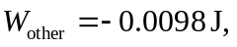 so and 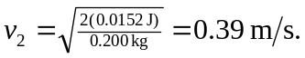
c) In this case, 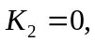 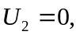 so

